AIML PROJECT

**Title: Simulation of 8-Puzzle Game**

**Questions and Possible Client Answers**

1. **What is your understanding of the 8-puzzle game?**

Answer: It's a puzzle where tiles are scrambled, and you need to organize them in order by moving one at a time into an empty slot.

1. **How do you feel about the user interface of the game?**

Answer: The UI is straightforward, but adding a dark mode would improve the overall look.

1. **Were the instructions clear on how to play the game?**
   * Answer: The instructions were clear, but maybe add some more examples for different starting configurations.
2. ***Which search algorithm (BFS, DFS, A, Greedy Best-First Search) did you find most efficient during gameplay?* \***
   * Answer: Breadth-First Search felt slow, but A* found the optimal path much faster.
3. **Did you experience any delays or performance issues during the search process?**
   * Answer: Sometimes the game took a bit longer to compute with DFS, but nothing too problematic.
4. **How effective were the heuristic functions like Manhattan distance and Misplaced Tiles in guiding the solution?**
   * Answer: They worked well, but I’m not sure I fully understand the difference between them.
5. **Were you satisfied with the explanation of how each algorithm works?**
   * Answer: The explanation was clear, but more details about when each algorithm is best used would help.
6. **Was the display of the game tree and node exploration clear and informative?**
   * Answer: It was clear, but an interactive visual would make it more engaging.
7. **Do you feel that the game simulation is an effective educational tool for learning AI algorithms?**
   * Answer: Definitely, it shows how different algorithms behave with the same problem.
8. **Did the performance metrics (time taken, nodes expanded, memory used) provide valuable insights?**
   * Answer: Definitely, it shows how different algorithms behave with the same problem.
9. **What additional metrics would you like to see in the performance analysis?**
   * Answer: A metric for the depth of the search might help understand how far each algorithm had to go.
10. **Do you find the visual representation of the game states (tiles and grid) easy to follow?**
    * Answer: Mostly, though sometimes I couldn’t immediately see the difference between tiles.
11. **How would you rate the overall ease of use of the simulation?**
    * Answer: It was easy to use, but the controls could be more responsive.
12. **How helpful was the comparison between different search algorithms?**
    * Answer: It helped clarify the trade-offs between speed and memory use for each algorithm.
13. **Did you find the solvability check for initial configurations useful?**
    * Answer: Yes, it was a nice feature to have.
14. **Were the solution path and number of moves clearly displayed?**
    * Answer: Yes, it was clear, though it could use a bit more visual emphasis.
15. **What improvements would you suggest for the output display (solution path, time, space complexity)?**
    * Answer: A graphical summary of the search process would be cool.
16. **Did the search algorithms always lead to an optimal solution in your experience?**
    * Answer: Most of the time, yes, but I noticed DFS sometimes took longer routes.
17. **Would you like additional puzzles or challenges added to the game for further learning?**
    * Answer: Absolutely, it would be great to try more challenging puzzles like a 15-puzzle.
18. **How likely are you to recommend this simulation for educational purposes in AI courses?**
    * Answer: Likely, as it provides practical exposure to theoretical concepts.

Geo-tag Photo: -

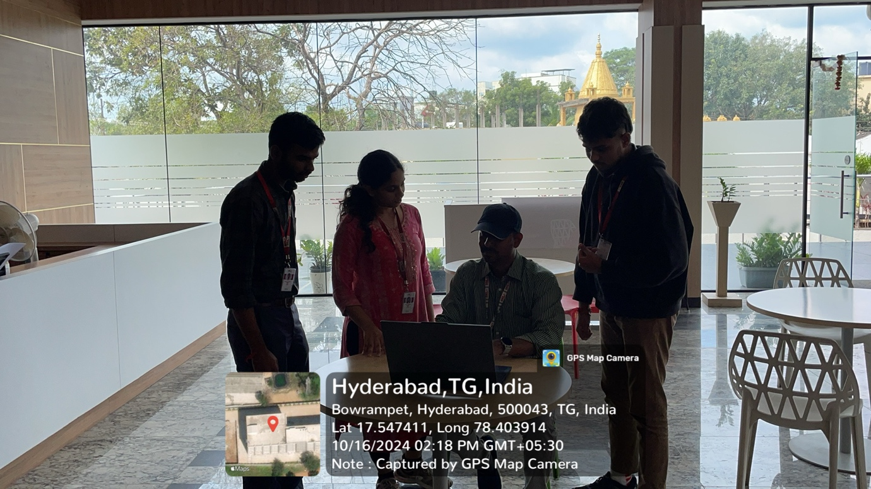

**Batch - 17**

**2320030182 - Sadhana**

**2320030185 - Avinash**

**2320030191 - Jayakrishna**